Internal Permanent Magnet Motors

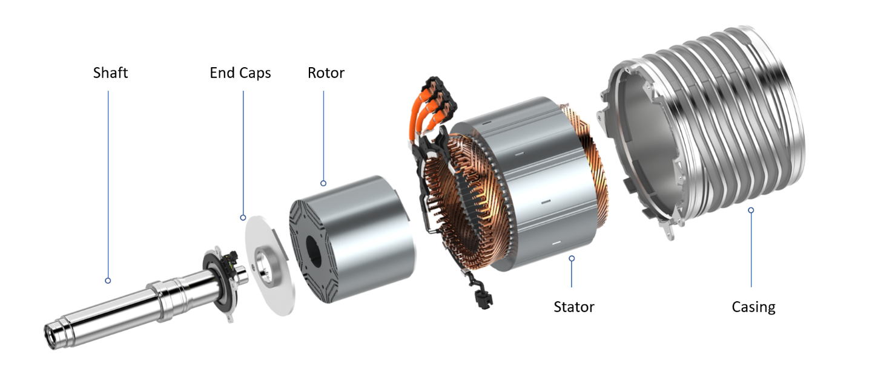

|  |  |  |
| --- | --- | --- |
| **Motor Series Parameters** |  | **Benefits** |
| Voltage Range – 48 V to 96 V |  | Highly efficient IPM motor > 94% |
| Peak Torque – 45 Nm to 250 Nm |  | Compact – Smaller size for easy integration |
| Continuous Power – 5 kW to 30 kW |  | Power Dense – Lesser Weight |
| Peak Power Capability – 8 kW to 45 kW |  | Advanced Cooling Design – Better Performance |
| Max. Operating Speed – 8,000 RPM |  | Modular – Multiple applications |

Applications



One size doesn’t fit all and the same is true for motors as well. For each application, different specifications (RPM, Torque, Efficiency etc.) of the motor is required and VoltWorks specializes in designing and developing the motor as per end customer use case.

IPSM HP-2W IP67

Our Internal Permanent Magnet Synchronous Motor (IPMSM) motors bring together best in class electromagnetic and thermal design through advanced research and development into hybrid and electric power technology. The motor suits for wide variety of traction applications for performance bikes and scooties.

|  |  |  |  |  |  |
| --- | --- | --- | --- | --- | --- |
| Voltage | Peak power | Cont. power | Peak torque | Weight | Max operating speed |
| 48 – 96V | 8 kW | 3-5 KW | 45 Nm | 10 kg | 6,750 RPM |

**Performance and Efficiency at 72 V | 5 kW continuous power**

**Dimensions**

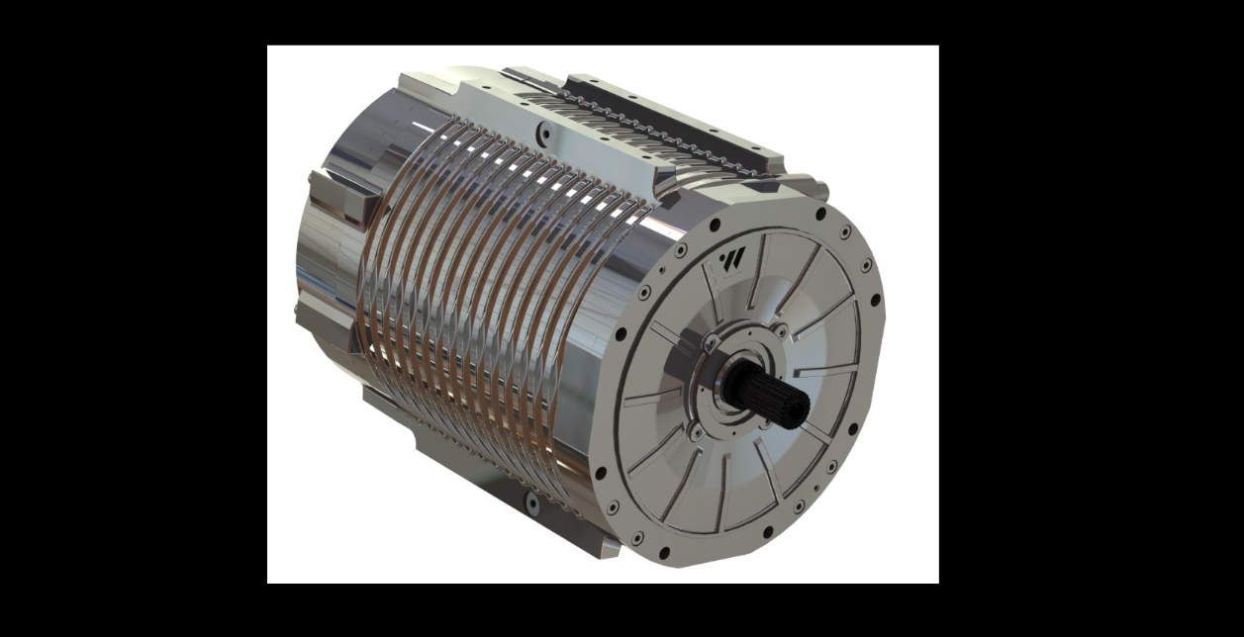

IPSM LP-3W IP67

Our Internal Permanent Magnet Synchronous Motor (IPMSM) motors bring together best in class electromagnetic and thermal design through advanced research and development into hybrid and electric power technology. The motor suits for wide variety of traction applications for performance bikes and scooties.

|  |  |  |  |  |  |
| --- | --- | --- | --- | --- | --- |
| Voltage | Peak power | Cont. power | Peak torque | Weight | Max operating speed |
| 48 – 96V | 8 kW | 3-5 KW | 45 Nm | 10 kg | 6,750 RPM |

**Performance and Efficiency at 72 V | 5 kW continuous power**

**Dimensions**

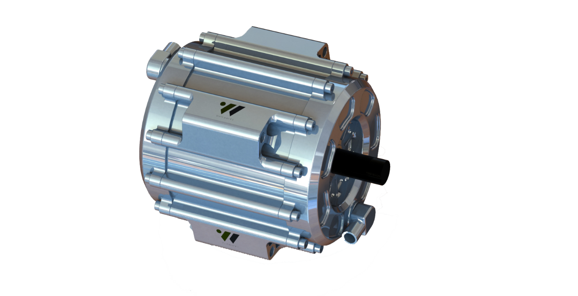

IPMSM HP-3W IP67

IPMSM LP-2W IP67

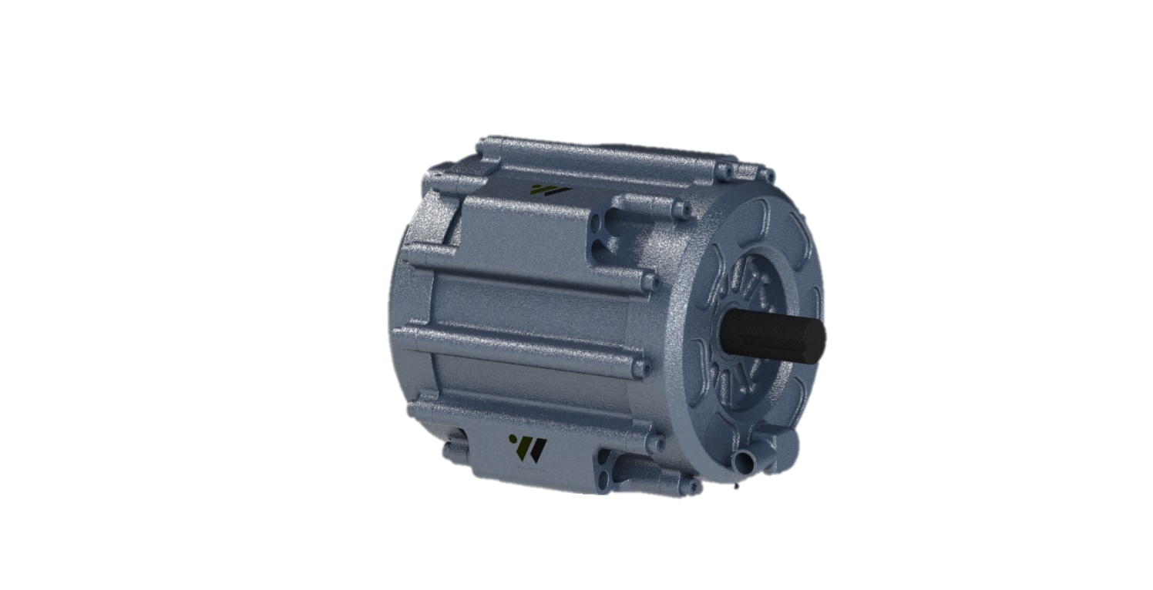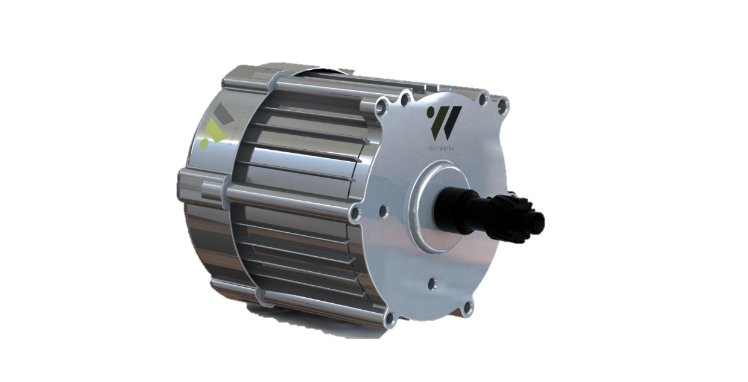

AND MANY MORE…

Contact Us

**VoltWorks Technologies Pvt. Ltd.**

**D-15 First Floor, Sector 10, Block D, Alpha I, Noida,**

**Uttar Pradesh 201301**

**Mob No.: +91-9651184831**

**Email:** [**info@voltworks.in**](mailto:info@voltworks.in)**,** [**himanshu.sahu@voltworks.in**](mailto:himanshu.sahu@voltworks.in)

**Web:** [**www.voltworks.in**](http://www.voltworks.in)